RK UNIVERSITY
School Of Engineering (SEP. – 2025) Semester – 5

Date: 9-9-2025 Branch: CE/IT
Subject Name: Enterprise Computing through .NET Framework Subject code: CE535

Answer Sheet

Division: CE - C Exam Time: 2:25 – 4:05 SET: 1
Enrollment No: 24SOECE13901 Name: Pandit Saurav N. Roll No: 54
----------------------------------------------------------------------------------------------------------------------------------

Instructions to Candidates:
- Please fill Division, Exam Time, Set of Paper, Enrollment No., Name & Roll No.
- You will save this file & upload your saved file with the file name is {rollno_enrollmentNo_name_Answersheet}.

This assessment is intended to test the hands on skills related C# Programming.

You must take screenshot of output and write code of each task solution.

Both screenshot and code (each task solution) must contain your Enrollment and Name.

Task_1  Ans. | using System;  using System.Collections.Generic;  using System.Linq;  using System.Text;  using System.Threading.Tasks;  namespace _24SOECE13901_Saurav_Pandit_CIE_1_EXAM  {  class Employee  {  public string EmpCode;  public string Name;  public string Designation;  public double BasicPay;  public double HRA;  public double DA;  public double TotalPay;  public Employee(string empCode, string name, string designation, double basicPay)  {  EmpCode = empCode;  Name = name;  Designation = designation;  BasicPay = basicPay;  }  public void CalPay()  {  HRA = 0.10 * BasicPay;  DA = 0.45 * BasicPay;  TotalPay = BasicPay + HRA + DA;  }  public void DisplayDetails()  {  Console.WriteLine("Employee Code: " + EmpCode);  Console.WriteLine("Name: " + Name);  Console.WriteLine("Designation: " + Designation);  Console.WriteLine("Basic Pay: " + BasicPay);  Console.WriteLine("HRA: " + HRA);  Console.WriteLine("DA: " + DA);  Console.WriteLine("Total Pay: " + TotalPay);  Console.WriteLine("-------------------------------");  }  }  internal class Q1  {  static void Main(string[] args)  {  Employee emp1 = new Employee("1001", "Saurav", "Manager", 5000);  Employee emp2 = new Employee("1003", "Denish", "Analyst", 3500);  emp1.CalPay();  emp1.DisplayDetails();  emp2.CalPay();  emp2.DisplayDetails();  }  }  }  Output :  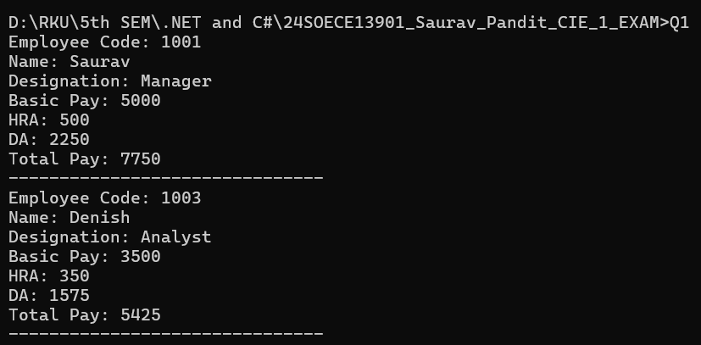
Task_2  Ans. | using System;  using System.Collections.Generic;  using System.Linq;  using System.Text;  using System.Threading.Tasks;  namespace _24SOECE13901_Saurav_Pandit_CIE_1_EXAM  {  internal class Q2  {  static void Main(string[] args)  {  int num = 1;  for (int i = 1; i <= 4; i++)  {  for (int j = 1; j <= i; j++)  {  Console.Write(num++ + " ");  }  Console.WriteLine();  }  }  }  }  Output :  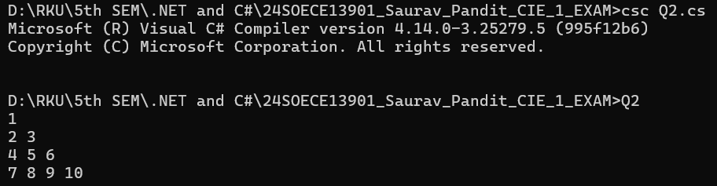
Task_3  Ans. | using System;  using System.Collections.Generic;  using System.Linq;  using System.Text;  using System.Threading.Tasks;  namespace _24SOECE13901_Saurav_Pandit_CIE_1_EXAM  {  internal class Q3  {  static void Main(string[] args)  {  int[] arr = {10,15,27,35,48,20,30,44,22,55};  Console.Write("Enter element to search: ");  int element = Convert.ToInt32(Console.ReadLine());  bool found = false;  for (int i = 0; i < arr.Length; i++)  {  if (arr[i] == element)  {  found = true;  break;  }  }  if (found)  Console.WriteLine(1);  else  Console.WriteLine(0);  }  }  }  Output :  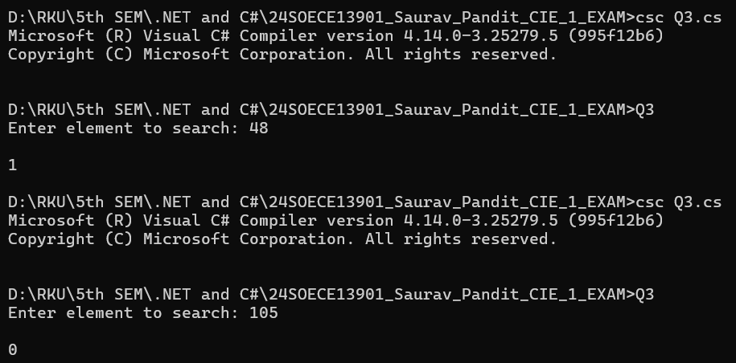
Task_4  Ans. | using System;  using System.Collections.Generic;  using System.ComponentModel;  using System.Data;  using System.Drawing;  using System.Linq;  using System.Text;  using System.Threading.Tasks;  using System.Windows.Forms;  namespace _24SOECE13901_Saurav_Pandit_CIE_1_Exam_Windows_Form_  {  public partial class Form1 : Form  {  Double firstNumber, secondNumber, answer;  string = "";  public Form1()  {  InitializeComponent();  }  private void radioButton1_CheckedChanged(object sender, EventArgs e)  {  }  }  }  Output:
Task_5  Ans. | using System;  using System.Collections.Generic;  using System.ComponentModel;  using System.Data;  using System.Drawing;  using System.Linq;  using System.Text;  using System.Threading.Tasks;  using System.Windows.Forms;  namespace _24SOECE13901_Saurav_Pandit_CIE_1_Exam_Windows_Form_  {  public partial class Form2 : Form  {  public Form2()  {  InitializeComponent();  }  private void textNumeric_Keypress(object sender, KeyPressEventArgs e)  {  if (!char.IsControl(e.KeyChar) && !char.IsDigit(e.KeyChar)) {  e.Handled = true;  }  }  private void textUpper_Keypress(object sender, KeyPressEventArgs e)  {  e.KeyChar = char.ToUpper(e.KeyChar);  if (!char.IsControl(e.KeyChar) && !char.IsLetter(e.KeyChar)) {  e.Handled = true;  }  }  private void textCharacter_Keypress(object sender, KeyPressEventArgs e)  {  if (!char.IsControl(e.KeyChar) && !char.IsLetter(e.KeyChar) && e.KeyChar != ' ') {  e.Handled = true;  }  }  }  }  Output :  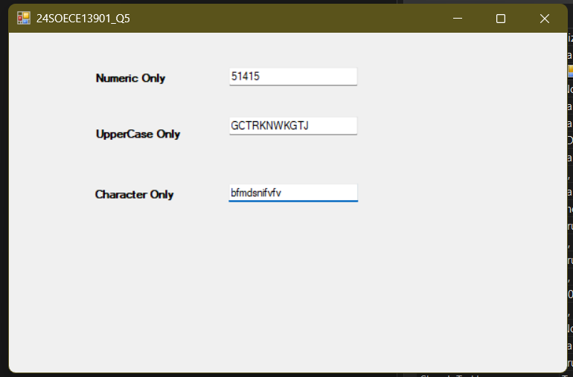
Task_6  Ans. | using System;  using System.Collections.Generic;  using System.Linq;  using System.Text;  using System.Threading.Tasks;  namespace _24SOECE13901_Saurav_Pandit_CIE_1_EXAM  {  class Book  {  public int bookId;  public string title;  public double price;  }  internal class Q6  {  static void Main(string[] args)  {  Book b1 = new Book();  b1.bookId = 1101;  b1.title = "Logic Building";  b1.price = 250.00;  //display first book details  Console.WriteLine("Book Id is : " + b1.bookId);  Console.WriteLine("Book Tittle is : " + b1.title);  Console.WriteLine("Book Price is : " + b1.price);  }  }  }  Output :  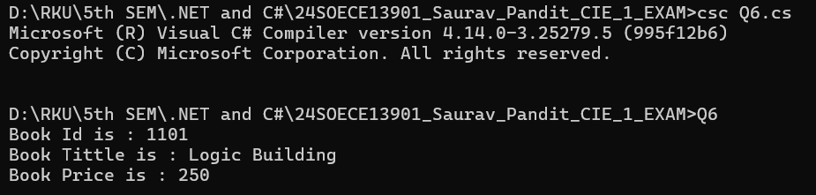
Task_7  Ans. | using System;  using System.Collections.Generic;  using System.Linq;  using System.Text;  using System.Threading.Tasks;  namespace _24SOECE13901_Saurav_Pandit_CIE_1_EXAM  {  class Demo  {  private int n1;  static int n2 = 10;  }  class DemoImplemented  {  public void Addition()  {  int m = n1 + n2;  }  public void Multiplication()  {  int s = n1 * n2;  }  }  internal class Q7  {  }  }

